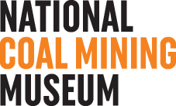 **Access Statement**

The National Coal Mining Museum for England aims to be accessible to all. The Museum is located on the original **Caphouse Colliery** and **Hope Pit** sites, and as such, many of the original buildings have been retained, to illustrate a working environment. As a result, in achieving a balance between authenticity and access, not all areas are easily accessed, particularly by wheelchair users.

Extra care must be taken when touring the site, especially between what were working buildings, as some surfaces may be uneven in places, partly caused by continuing subsidence, with mine workings beneath. Every effort is made to avoid potentially hazardous surfaces, and visitors are advised to stick where possible to clearly even and firm surfaces, not taking short cuts over uneven, unmarked routes.

Guide dogs and assistance dogs are welcome at the museum, with a water bowl positioned outside the Café.

Any special requirements or queries you may have regarding accessibility can be discussed in advance of your visit, and staff will endeavour to ensure your visit is as enjoyable as possible.

Please contact reception on: 01924 848 806

**Parking**

There are 10 designated blue badge car-parking spaces alongside the main building close to the **main entrance.** There is level access from these spaces into the **Main Entrance building**.

For the **Hope Pit site**, car parking is available either at the top of the site or adjoining the various buildings, and, whilst there are no designated blue badge spaces, there is usually the facility to park on the aprons in front of the Hope Workshop and Hope Store.

Please ask at reception if you would like more information about parking across the site.

**Toilets**

Male, Female and Accessible toilets are available in three locations across the site: within the Main Entrance Building, to the rear of Hope Pit Workshop Building, the Pony Discovery Centre and at the rear of the building with the Pithead Baths. There is a shower located in the Accessible toilet within the Main Entrance Building.

**Travelling around the National Coal Mining Museum site**

This is a large site with 4 main zones **The Hub** and **Caphouse Zone**, **Hope Pit** and **Pit Wood**. The Hub and Caphouse sit on the former Caphouse Colliery site, Hope Pit is 350m away and Pit Wood straddles the two.

The bulk of the main **Caphouse Colliery site** is reasonably level, with tarmac and concrete surfaces between buildings and pedestrian routes clearly signed. However, there is a section of the site at a considerably lower level that incorporates the Pithead Baths and toilets. Access to this part of the site is either via a long sloped road, with a gradient of around 1:12, or a steep and long set of stairs with handrails each side.

Maximum travelling distance between buildings is approximately 50m on the main site, with level access to the Lamproom, Underground Tours buildings, and the Steam Winding Room. There is a 10m (approximately) sloped area, maximum gradient around 1:12 to access the 1842 gallery. There is a slight slope, approximately 1:18, between the Steam Winding Room, Control Room and Coal Interface Gallery Buildings.

The Hope Pit site is approximately 350m from the Caphouse Colliery site and is connected by a road with parallel railway track. Travelling between sites can be along a pedestrian route beside the road, via the museum train (when running), or by car.

The **Hope Pit site** has greater distances between buildings. The central area is reasonably level, with a slightly graded tarmac route to the Hope Store, and a tarmac-surfaced wide footpath route, with a gradient of a maximum 1:12 to the Winding Engine building. All routes are surfaced with tarmac or gravel but some areas between buildings are uneven.

The Nature Trail can be accessed via the **Hope Pit site** or the **Caphouse Colliery Site** and is between ½ mile and a mile in length, depending on route taken.

The whole Museum site has directional signage with way finder maps positioned at key locations.

CAPHOUSE COLLIERY SITE

# The Caphouse Colliery site contains the majority of the museum buildings including; The Hub, Lamproom and Underground Tour, Victorian Gallery, Pithead baths, Technology Gallery and the Steam Winding Room

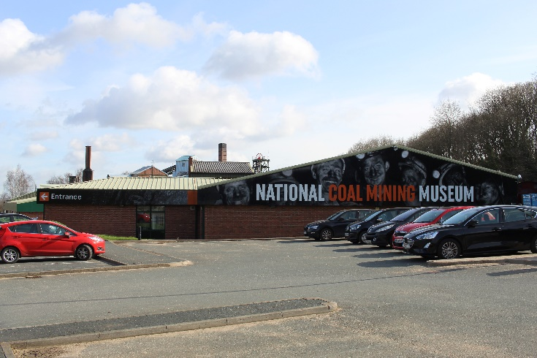

The Hub

The **Hub, which is the main entrance building** is a single storey, modern build with level entry access via automatic doors. It incorporates; Reception Desk, Shop, toilets, Mining Lives Gallery, Learning Spaces, Conference Centre, Library and Café.

# Reception Desk

The reception desk is directly opposite the **Main Entrance** and has a lower section of counter, and a sound induction loop to assist visitors using hearing aids. Museum information leaflets and a colour map of the site are available to collect here. Staff are available to provide information and book visitors into the Underground Tours.

2 wheelchairs are available to borrow from the reception desk. These can be booked in advance by contacting reception or used on the day of visit when available.

# Toilets

Male and female standard toilets are located in a lobby behind the Reception area.

An accessible toilet with shower and standard toilets are available between the café and conference centre.

Shop

The shop is located adjacent to the reception desk with good circulation space from the reception desk to the shop area, and most items on display at an accessible height. Staff are available to assist anyone with difficulty reaching items.

# Mining Lives Gallery

This gallery is located between the shop and the café and has a lower and upper level connected by a ramp with handrail. There is good circulation space throughout the gallery areas, and some seating.

Some of the exhibits are in open displays, and others are within glass cabinets, with clear print labels and information boards. On the upper level are some tactile images. TV monitor screen information is accompanied by audio and subtitles. A small theatre area with TV video has restricted space, but is accessible by a wheelchair user, who may have to reverse out.

The rest of the museum site can be accessed via a rear manual single door to an external ramp with handrail.

# Café

Accessed from the top level of the Mining Lives Gallery or from the shop space via a ramp and short flight of stairs with handrails. The café has ample circulation space around the service counter, with a tray shelf at a suitable height for wheelchair users. There is reasonable space between tables, but this could be a little restricting in the centre for wheelchair users and ambulant disabled people with walking aids.

Learning Space

The Learning Space teaching rooms are accessed from a lobby to the side of the reception desk with level access via the main entrance. There are double doors, both needing to be used to gain sufficient width for wheelchair access. In the teaching rooms, the doors have finger guard strips covering the hinges, resulting in 730mm clear door opening width, a little tight for standard-sized wheelchairs.

# Conference Centre

The conference facilities are in the main building and can be accessed via a self-contained level access with automatic doors or via the cafe. The conference room can be one or divided into three and has sufficient door width for wheelchair access.

There is audio-visual equipment available to use in the conference centre but no induction loop.

Library

The library is accessed via the Conference Centre and has sufficient door width for wheelchair users. Inside a Librarian is available to support selection of books and there are adjustable-height tables with seating.

# The Lamproom & Furnace Shaft

The approach is via a short ramp into a small display area, which has clearly labelled exhibits, and some interactive features, all within accessible reach.

There is a level route into the Lamproom past display exhibits, with a queue barrier area towards the lamp-collection point for the Underground Tour. As the exit from this area is through a narrow passage to the outside, there is an alternative side door for wheelchair users, adjacent to the Furnace Shaft Viewing Area.

The **Furnace Shaft Viewing Area** can be accessed via the Lamproom or via level access from the side of the Underground Tour Building. Viewing of the shaft is through a glass top and due to its depth could cause disorientation for visitors who experience vertigo.

# Underground Tour

Prior to entering the tour, visitors must collect battery packs that are attached to a shoulder strap, weighing around 1kgs/2 lbs, as well as a lamp to carry, and hardhat to wear. The battery pack can be attached to a wheelchair.

All electronic equipment must be left in the Lamproom, but medical equipment users (inc. Hearing Aids, Glucose Monitors) can retain their aids. If you have any queries about specific aids, please contact the Museum.

Electric wheelchairs are not permitted because of the interference from batteries. A standard manual wheelchair is available for use and there is a transfer hoist available if required. For safety reasons, all wheelchair users are required to use seatbelts provided by the Museum.

There is a limit of 1 wheelchair underground at any one time, for safety reasons. A maximum of 6 people can accompany 1 wheelchair user, to enable safe evacuation.

Accompanied by a mine guide, visitors descend 140 metres to the tour in a working cage. The cage has a handrail and low lighting.

The full underground tour covers a distance of around 600m in total. Both tours are fully accompanied, with explanations and information from an experienced guide, who also has strict safety procedures to follow. Much of the time is spent travelling along the walkways, with very limited opportunity to sit and rest. As this is in an authentic mine, there are uneven floors, of varying widths, and also some low roofs that necessitate bending and stooped walking in places.

Staff will endeavour to provide tours tailored to the needs of visitors with disabilities; please contact the museum in advance of your visit to discuss any additional requirements.

# Technology Gallery

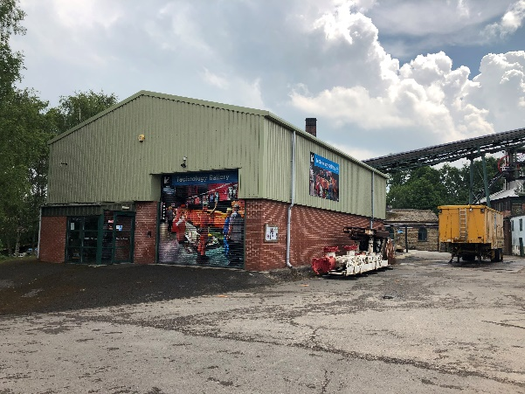This is a modern building with a short, easy gradient ramp to an automatic single-door entry. There are two floors of displays that include large items of machinery, mostly with clear labels and information posters and some interactive features.

Between floors is a steep set of metal stairs with handrails located next to the entrance, and a passenger lift located in the centre of the gallery, the latter having clear tactile controls.

There is generally reasonable circulation space between exhibits, and a good level of lighting throughout. Some of the recorded sounds from displays produce a potential clash of sound.

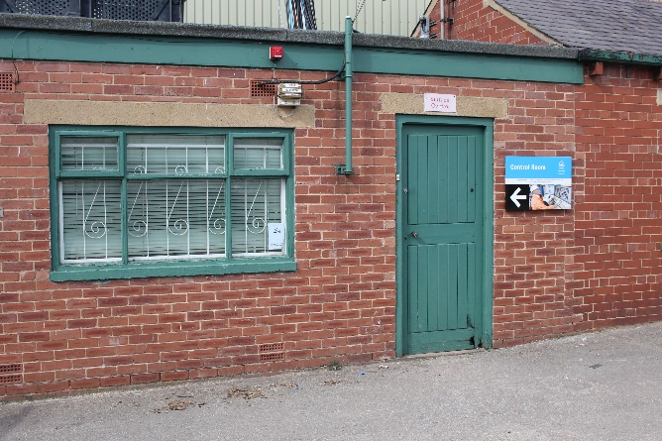**Control Room**

This small room has level access via an entrance lobby, but very restricted internal circulation and turning space, with a small step up into the main room. There are glass viewing panels into the control room.

# The Steam Winding Room

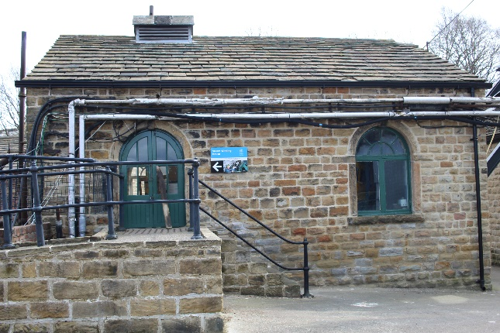

There is combined ramp-and-stairs access to the building. Once inside there is a very small viewing platform, and very narrow short flight of stairs to the lower area, which is not accessible by a wheelchair user. There are interactive switches on the top level, within accessible reach, however there is very limited turning space.

# Victorian Gallery

This is a small building located behind the Steam Winding Room. It with level, automatic-door access, but the head height is restricted. It contains gallery scenes reproduced from Victorian times, with low lighting levels. Routes are accessible by wheelchair and there is a continuous audible commentary. Seating is located in the entrance. There are large clearly printed information signs.

# Pithead Baths

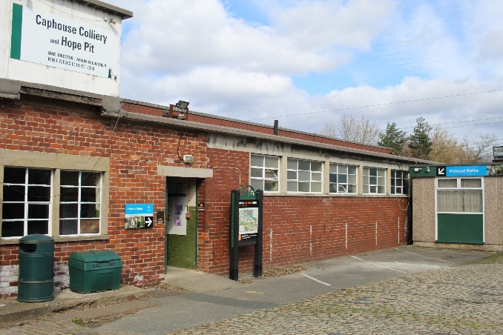This building has been retained in its original state with a short ramp to the entrance. Visitors are able to view showers and changing areas, as well as the First Aid Room, from a level central corridor ramp.

The corridors are narrow at points and there is a small step down into the shower area. There is an audio track that plays automatically in the First Aid area.

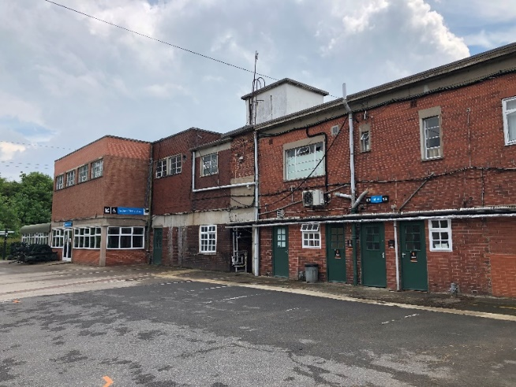Located behind the Pithead Baths,   
male and female toilets are accessed via green doors.

An accessible toilet is accessed via a short ramp and through double white-framed glass doors with a sign above ‘’Indoor Picnic Area’.

## HOPE PIT SITE

# The Hope Pit Site is located 350m from the Main Building and contains Power House , Blacksmiths, toilets, Compressor House, Fan House, Winding Engine House, Memorial Garden and Inman Shaft

# Power House (Only open on certain days, check with Reception)

A modern purpose-built building, with level access to the entrance via a lobby, there are good-width manual single doors at each end of the lobby, of suitable width for wheelchair access.

Most of the display area on the ground floor is an open area, with good lighting and circulation, and displays have clear information labels.

The first floor is accessed either by a staircase with handrails each side, or a passenger lift, with tactile buttons to the control panel.

On the first floor is a small viewing gallery, so as to be able to see the work being carried out in the Workshop through a low viewing window.

On the first floor are standard toilets and an accessible toilet.

# Workshop Building

There is level access through a single green door, with adequate width for a wheelchair user. There are low light levels in this space, particularly on a cloudy day.

The exhibition area has good circulation space, and there are clear glass screens around equipment to allow viewing, as well as lit glass cabinets with display material. There is a pre-recorded commentary and video on an overhead monitor, with subtitles. The adjoining garage contents can be viewed through an open mesh partition. Example tools are available to touch on the workbenches.

At the rear of the workshop is a working forge area that is used for demonstrations, when running this creates significant background noise and smells.

# Toilets

Male and Female toilets and an Accessible Toilet are located to the rear of the Workshop Building with external-level access from a gravel footpath.

# Compressor House

# Double doors provide level access to this building, with suitable width in single leaf for wheelchair access.

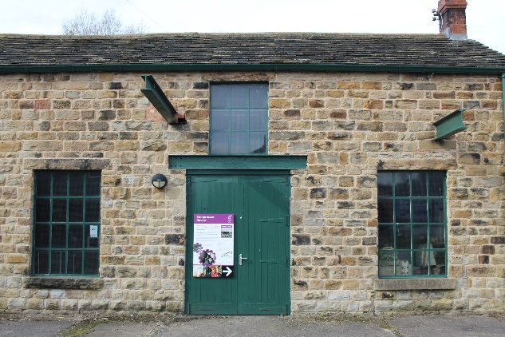

There is a completely level interior, with good circulation space, low level glazed screens for viewing, and clear signage and labels.

There are low light levels in this space, particularly on a cloudy day. There is a pipe positioned at head height (187cm) that visitors need to be cautious of.

# Fan House

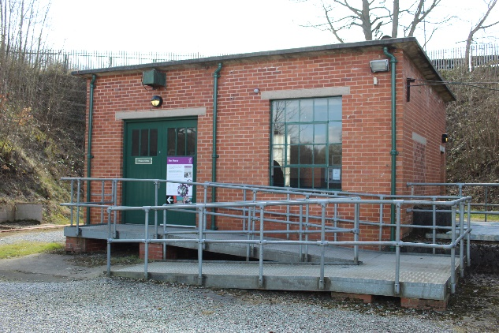This building is accessed via an aluminium ramp with handrails each side, intermediate platform and a gradient of approximately 1:15. The level entrance is then through double manual heavy doors, with each leaf 1 metre wide.

There is a decent lighting level and good circulation between work display areas that are on platforms. The interactive parts of the table display can be reached from the level route, as well as from the raised platform. There are other small items displayed and clearly labelled in lit glass cabinets.

# Winding Engine House

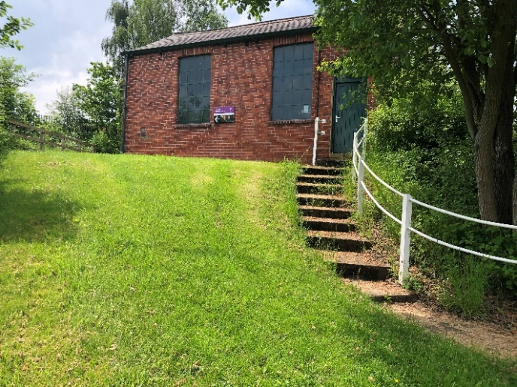A very small building that is approached from the rest of the site up a sloped footpath. At its entrance are double doors, which both need to be opened to allow wheelchair access.

Internally there is a viewing area, at its narrowest 750mm and at its widest 2 metres. There are two touch button screens at 900mm height.

There is an audio commentary that plays automatically.

# Memorial Garden

Located next to the train platform the Memorial Garden can be accessed via a narrow slope next to the platform, via the Hope Store pathway or via a gate, suitable for wheelchair access, passing over the railway line on a level tarmac path.

The garden has a combination of grassed areas with pebbledash and cobbled pathways, some of which are quite uneven. It contains a collection of sculptures with various seating areas, some with backs and arms.

# Inman Shaft

This building is on a sloped section of site, separated from the rest of the Hope Pit by the railway line. Its first floor is approached via a gate, suitable for wheelchair access. Passing over the railway line on a level tarmac path or via the Memorial Garden and bridge gives level access to the first floor.

A graded tarmac footpath, approximately 1:15, goes around the building to give separate level access to the ground floor. Some of the corners of this pathway have tight widths. Doors into both levels are single manual doors, of suitable width for wheelchair access.

Internally, there is a reasonable lighting level and circulation, and interactive displays at accessible heights.

**NATURE TRAIL**

**The Nature Trail can be accessed from both the Hope Pit Site and the Caphouse Colliery site. The first option providing the most level access to the bird hides. It should be noted that this trail has a variety of slopes some of which are very steep and as the paths have been left as natural as possible there are uneven sections. There is moss covering stoned sections paths, and in adverse weather the paths can become very muddy.**

At between ½ mile and a mile the Nature Trail is very difficult terrain for a wheelchair user or those with limited mobility, and a carer/companion would need stamina to push a wheelchair along much of the route. If you have an electric wheelchair or scooter, make sure the batteries are fully charged before entering the trail.

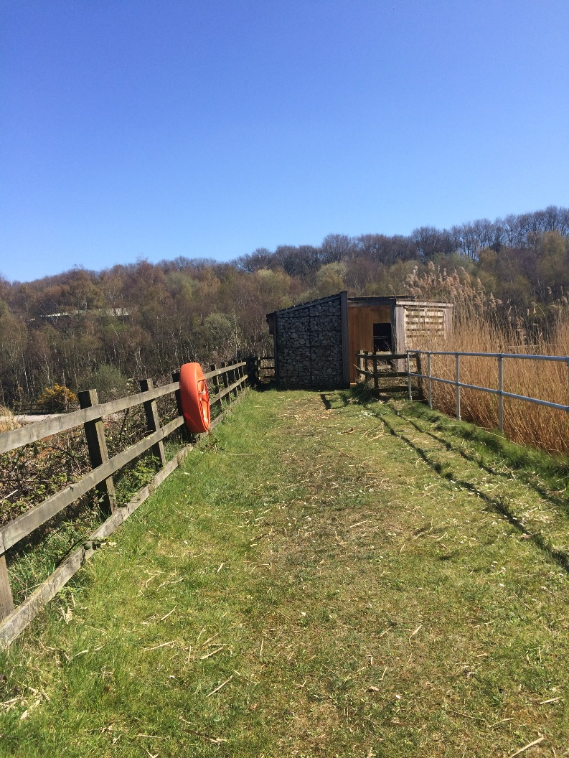**From Hope Pit site**, the routes around the Water Treatment Lagoons lead down the hillside. They link with the stoned, reasonably level path in the bottom of the valley, which is the start of the nature trail. There are two bird-viewing hides, on the slopes adjoining the ponds; these are accessible for wheelchair users.

From **Caphouse Colliery main site**, access to the Nature Trail is by way of a part-concrete and   
part-stoned path, reasonably level at first, across the railway line and past the Adventure Playground.

The path then progressively steepens through woodland, with a set of stone steps to lower paths. To avoid the steps there is an alternative route down a long slope, with a gradient of approximately 1:15.

There are a few benches available along the woodland stretch of the trail and two picnic areas.

# Water Treatment Lagoons

These ponds are most easily accessible from **Hope Pit Site** and are mainly fenced off, although can be seen from the wide adjoining footpaths, which have stoned surfaces that are a little uneven in places, and of varying gradients, as steep as 1:10 in places.

Some reed beds are unprotected so that care should be taken. The only seats along the routes are in the picnic area, on a sloped hillside near one of the bird viewing hides.

Pony Discovery Centre

The Pony Discovery Centre is in Pit Wood approached via a tarmacked path with a slight upward slope from The Power House, which is suitable for wheelchair access.

Internally, there is good lighting and circulation, and interactive displays at accessible heights.

The doors into the classroom can be accessed by an internal ramp to manual doors, of suitable width for wheelchair access.

There is also an accessible toilet.

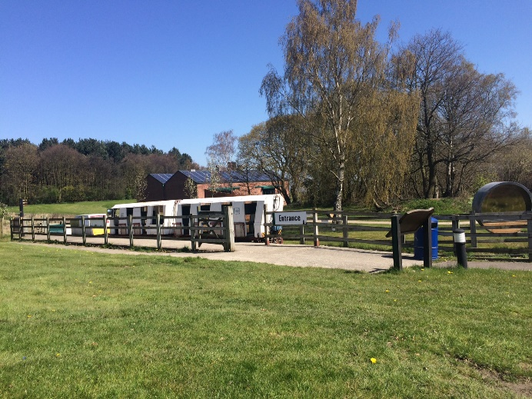**SPECIAL TOURS/EVENTS**

Paddy Train

# The museum train service has ramped access to the platforms, with handrails, and one train carriage has been adapted to carry one wheelchair user with assistance from trained staff.

# Screens Building (only open 2 days per year for special events)

This building is currently in its original working state and only the first floor is accessible to the public, but always with a trained guide during special events. It is approached by a steep external metal fire-escape staircase. Once inside there is a small area for a talk by the guide, and the guide accompanies the rest of the tour to the building. This involves climbing short flights of narrow stairs and negotiating a covered ramped corridor between two sections of the building. The building contains original machinery although not working at present.

Updated June 2023