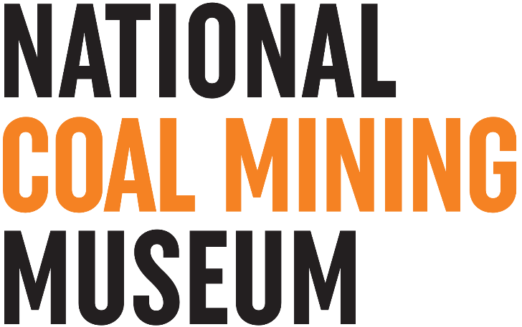

NATIONAL COAL MINING MUSEUM FOR ENGLAND

Recruitment of Mine Director and Head of Estate Management

Background Information – The Museum

The National Coal Mining Museum for England is located at the historic Caphouse Colliery, on the A642 half way between Wakefield and Huddersfield. Caphouse Colliery is the only surviving intact nineteenth-century colliery in the country and has the oldest shaft still in use in the United Kingdom. The underground tour open to the public is located in the New Hard Seam at a depth of 140 metres, with 600 metres of roadways. The displays underground show the history of mining from the early-nineteenth century up to the present day and educational facilities are provided underground for schools. As well as the shaft, the underground can be accessed by a one-in-four 600-metre long drift. As well as Caphouse Colliery, the Museum owns the adjacent Hope Pit and fields to the north of the Museum.

The Museum (as Yorkshire Mining Museum) opened to the public on 6 June 1988. It gained national status in the 1990s becoming the National Coal Mining Museum for England Trust Ltd. From 1999 the Museum’s revenue budget has been funded on an ongoing basis from the budget of the Science Museum Group (SMG) via the Department for Culture, Media and Sport. The relationship is managed by a Memorandum of Understanding which includes reporting of key performance indicators. As a National Museum entry to the site is free, but donations are requested for the Underground tours.

The National Coal Mining Museum for England is a Charity (Charity Number 517325) and comprises two legal entities:
  - National Coal Mining Museum for England Trust Ltd, a company limited by guarantee
  - National Coal Mining Museum Trading Limited, a wholly owned trading subsidiary.

Mine Regulations 2014
Uniquely the Museum is also an active mine governed by the Mine Regulations of 2014 and conforms to some of the most restrictive health and safety conditions of any public attraction. The Board of Trustees of the Charity are the Mine Owner/Operator under the regulations.

The Mine Director is supported by a team including Deputy Mine Manager, Electrical Engineer, Mechanical Engineer, Safety Manager, electricians, fitters and guides.

Mine water levels are controlled by pumping within the Museum and at Hope shaft which is interconnected with other former mines in West Yorkshire. Iron rich mine water is effectively treated by a passive mine water treatment scheme and data on mine water levels from the mines around the Museum is collected and interpreted by the Museum staff.

Wider Site
The site also houses nationally significant collections for English coal mining, covering engineering and technology, social history and fine art. Two key galleries - Mining Lives and the Technology Gallery - currently exhibit part of this collection. The Museum is also home to an extensive research library. In addition, there are also outdoor public spaces including play park, the Pony Discovery Centre, an operational Paddy train, water treatment lagoons, a nature trail and memorial garden. Indoors there are education spaces for formal and informal learning activity, a café, a shop and conference rooms.

At National Coal Mining Museum for England (NCMME), the objects of our Charity are

‘to advance the education of the public in the history of coal mining in England by the provision and maintenance of a museum both underground and on the surface at the former Caphouse Colliery for the demonstration of past and contemporary mining methods and the exhibition of machinery and other items connected with mining and industrial archaeology.’

Our Vision
National Coal Mining Museum for England will be widely recognised for using innovative, sustainable, relevant, accessible and exciting ways to share the stories of coal mining and its legacy. As a must-see museum and heritage attraction, and a significant part of the North of England’s visitor economy, we will provide a unique, enjoyable and distinctive experience for visitors.

Our Mission

National Coal Mining Museum for England’s mission is to keep the stories of coal mining alive by collecting and preserving the industry’s rich heritage. We co-create enjoyable and inspiring ways for people of all ages, backgrounds and needs to engage with the history of coal and its legacy.

Strategic Objectives

 | Strategic Objective
1 | Tell the inspiring story of coal mining - from zero to hero to net zero - becoming widely recognised for using innovative, modern and exciting ways to do this.
2 | Be a hub for our communities, including national, coal mining and local; and we will create opportunities for everyone to learn, share stories and celebrate coal mining, its history and culture.
3 | Preserve, maintain and develop the entirety of our site, underground and collections, investing in our people and deepening our governance and operational expertise in order to be successful.
4 | Transform our offer across the whole site, providing a fantastically resonant visitor experience.
5 | Collaborate with our fellow cultural and tourism partners in order to attract people to visit and engage with NCMME.

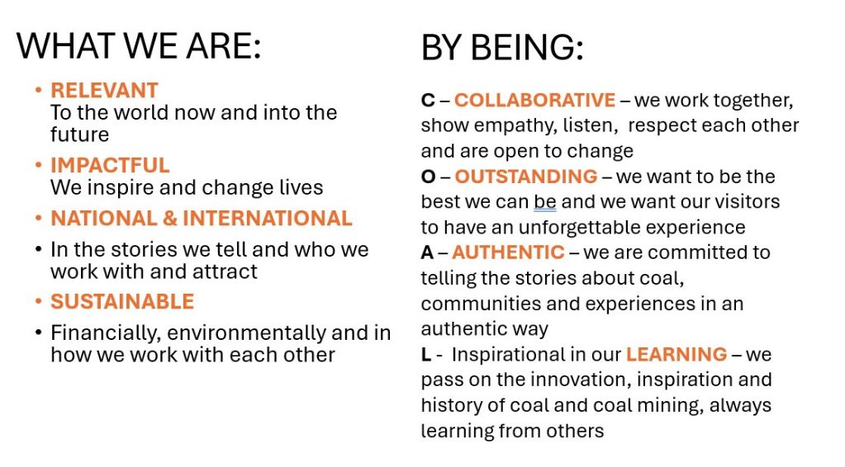

The Museum is currently refining its’ Masterplan for the next 10 years with significant investment planned. The first stage of this has seen the opening of a new Time Tunnel Experience at Hope Pit.

A detailed job description is enclosed with this application pack.

There are various employee benefits and policies, some of which are listed below:

- Free parking on Museum site
- 20% discount in shop and cafe
- Pension Scheme
- Commitment to continuing training and development of employees
- Employee Assistance Programme
- 38 days holiday (including Bank Holidays)
- 36 hour week (reduced hours will be considered)

If you would like a conversation about the role, please email our CEO to set up a
convenient time: lynn.dunning@ncm.org.uk

